**Statistic Terms**

* **Skewness**

**Skewness** is a measure of the asymmetry of a distribution. A distribution is asymmetrical when its left and right side are not mirror images.

A distribution can have right (or positive), left (or negative), or zero skewness.

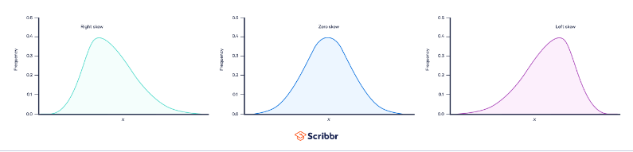

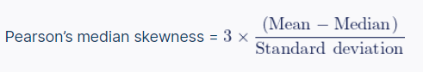**To calculate skewness, we can use Pearson's median skewness**.

* **Variance**

the term variance refers to a statistical measurement of the spread between numbers in a data set. More specifically, variance measures how far each number in the set is from the [mean](https://www.investopedia.com/terms/m/mean.asp) (average), and thus from every other number in the set.

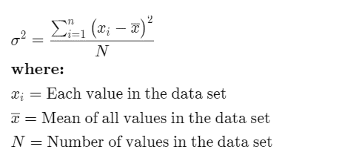To calculate Variance, we can use the following formula:

* **Advantages**

1. Statisticians use variance to analyze the relationship between individual numbers within a data set.
2. Variance is preferred over broader mathematical techniques like arranging numbers into quartiles.
3. Variance treats all deviations from the mean equally, regardless of their direction.
4. Variance avoids the issue of squared deviations summing to zero, which could incorrectly indicate no variability in the data.

* **Disadvantage**

1. A drawback of variance is that it gives more significance to outliers, which are numbers significantly different from the mean.
2. Squaring outliers when calculating variance can distort the overall data.
3. Another pitfall of using variance is that it is not easily interpretable on its own.
4. Users often take the square root of the variance to obtain the standard deviation, which provides a more intuitive measure of data variability.
5. Standard deviation is commonly used by investors to assess the consistency of returns over time

* **Standard Deviation**

**Standard deviation** is a statistic that measures the dispersion of a dataset relative to its [mean](https://www.investopedia.com/terms/m/mean.asp) and is calculated as the square root of the [variance](https://www.investopedia.com/terms/v/variance.asp). The standard deviation is [calculated](https://www.investopedia.com/ask/answers/021115/what-difference-between-standard-deviation-and-z-score.asp) as the square root of variance by determining each data point's deviation relative to the mean.

If the data points are **further from the mean**, there is **a higher deviation** within the data set; thus, the more spread out the data, the higher the standard deviation.

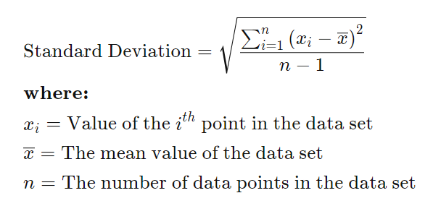To calculate standard deviation, we can use the following formula:

* **Strengths of Standard Deviation**

1. Standard deviation is a commonly used measure of dispersion in various fields, and analysts are often more familiar with it compared to other statistical calculations of data deviation.
2. Standard deviation is inclusive of all observations in the analysis, unlike other measures like range that only consider the most dispersed points without considering points in between.
3. Due to its inclusiveness, standard deviation is considered a more robust and accurate measurement compared to other observations.
4. The standard deviation of two data sets can be combined using a specific formula, whereas there are no similar formulas for other measures of dispersion in statistics.
5. Unlike other measures, standard deviation can be used in further algebraic computations, making it a versatile tool in data analysis.

* **Limitations of Standard Deviation**

1. Standard deviation does not directly measure how far a data point is from the mean; instead, it compares the squared differences, which is a subtle but important distinction from actual dispersion.
2. Outliers have a greater impact on standard deviation, as the squared differences result in even larger values compared to other data points. This means extreme values are given more weight in the calculation.
3. Manual calculation of standard deviation can be challenging and prone to computational errors, unlike simpler measures like range (highest value minus lowest value).
4. The use of a Bloomberg terminal can help overcome the difficulty of manual calculation and facilitate the computation of standard deviation.